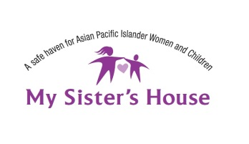
Employment Advocate

The Employment Advocate is hired by the Executive Director and will report to the Employment and Immigration Program Manager of My Sister’s House and assist in the following responsibilities:
- Provide direct services and case management to Women to Work clients, including conducting support and training groups.
- Assist clients in developing resumes, conducting job searches, and preparing for job interviews.
- Conduct intake and screening of new clients in accordance to established criteria.
- Provide case management support and crisis intervention to help line clients.
- Maintain accurate and up to date client records, statistics and information.
- Respond to clients’ crisis calls.
- Participate and represent My Sister’s House at various community and collaborative meetings, including conducting community outreach presentations.
- Other duties as assigned.

Qualifications:
- Bachelors in Psychology/Social Work or demonstrated experience (either paid or volunteer) in working in domestic violence or violence against women field required and/or employment readiness.
- Able to work with diverse populations, including Asian and Pacific Islander ethnic groups, youth, immigrants, refugees, lesbians, transgender, physically and mentally challenged, a wide age range from infants to elderly.
- Experience in working with domestic violence victims.
- Strong communication skills including writing and public speaking abilities required. Conflict resolution skills are highly desirable. Bilingual skills helpful. (Chinese, Hmong, or other Asian Pacific Islander language ideal.)
- Ability to manage multiple tasks and projects simultaneously and efficiently with minimal supervision.
- Ability to use email and MS Office 2000 programs.
- Valid driver’s license and ability to use personal vehicle for work; proof of car insurance.
- Ability to work as part of a team.
- A strong commitment to helping women and children in need.

Position: 40 hours / week / Full-Time – some weekends and evenings
Starting Salary: $16.00 per hour
Deadline to apply: Open until filled.
To Apply: Mail resume and cover letter to:
My Sister’s House
Attn: Executive Director
3053 Freeport Blvd #120, Sacramento, CA 95818

