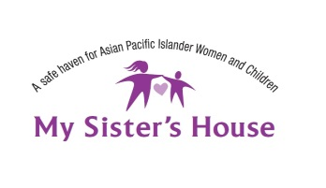
Employment Advocate

My Sister’s House began in 2000 as a public campaign to establish the organization as Sacramento’s (in fact the Central Valley’s) first agency to address battering in the Asian and Pacific Islander community. This included providing the development of a culturally appropriate safe haven. Its mission was and continues to be “to serve the needs of Asian and Pacific Islander women and children impacted by domestic violence by providing a culturally competent safe haven that empowers them to achieve a life of human dignity.”

The Employment Advocate is hired by the Executive Director and will report to the Employment and Immigration Senior Advocate of My Sister’s House and assist in the following responsibilities:
- Provide direct services and case management to Women to Work clients, including conducting support and training groups.
- Assist clients in developing resumes, conducting job searches, and preparing for job interviews.
- Conduct intake and screening of new clients in accordance to established criteria.
- Provide case management support and crisis intervention to help line clients.
- Maintain accurate and up to date client records, statistics and information.
- Respond to clients’ crisis calls.
- Participate and represent My Sister’s House at various community and collaborative meetings.
- Conduct community outreach presentations on domestic violence issues as directed.
- Other duties as assigned.

Qualifications:
- Bachelors in Psychology/Social Work or demonstrated experience (either paid or volunteer) in working in domestic violence or violence against women field required.
- Able to work with diverse populations, including Asian and Pacific Islander ethnic groups, youth, immigrants, refugees, lesbians, transgender, physically and mentally challenged, a wide age range from infants to elderly.
- Experience in working with domestic violence victims.
- Strong communication skills including writing and public speaking abilities required. Conflict resolution skills are highly desirable. Bilingual skills helpful. (Chinese, Hmong, or other Asian Pacific Islander language ideal.)
- Ability to manage multiple tasks and projects simultaneously and efficiently with minimal supervision.
- Ability to use email and MS Office 2000 programs.
- Valid driver’s license and ability to use personal vehicle for work; proof of car insurance.
- Ability to work as part of a team.
- A strong commitment to helping women and children in need.

